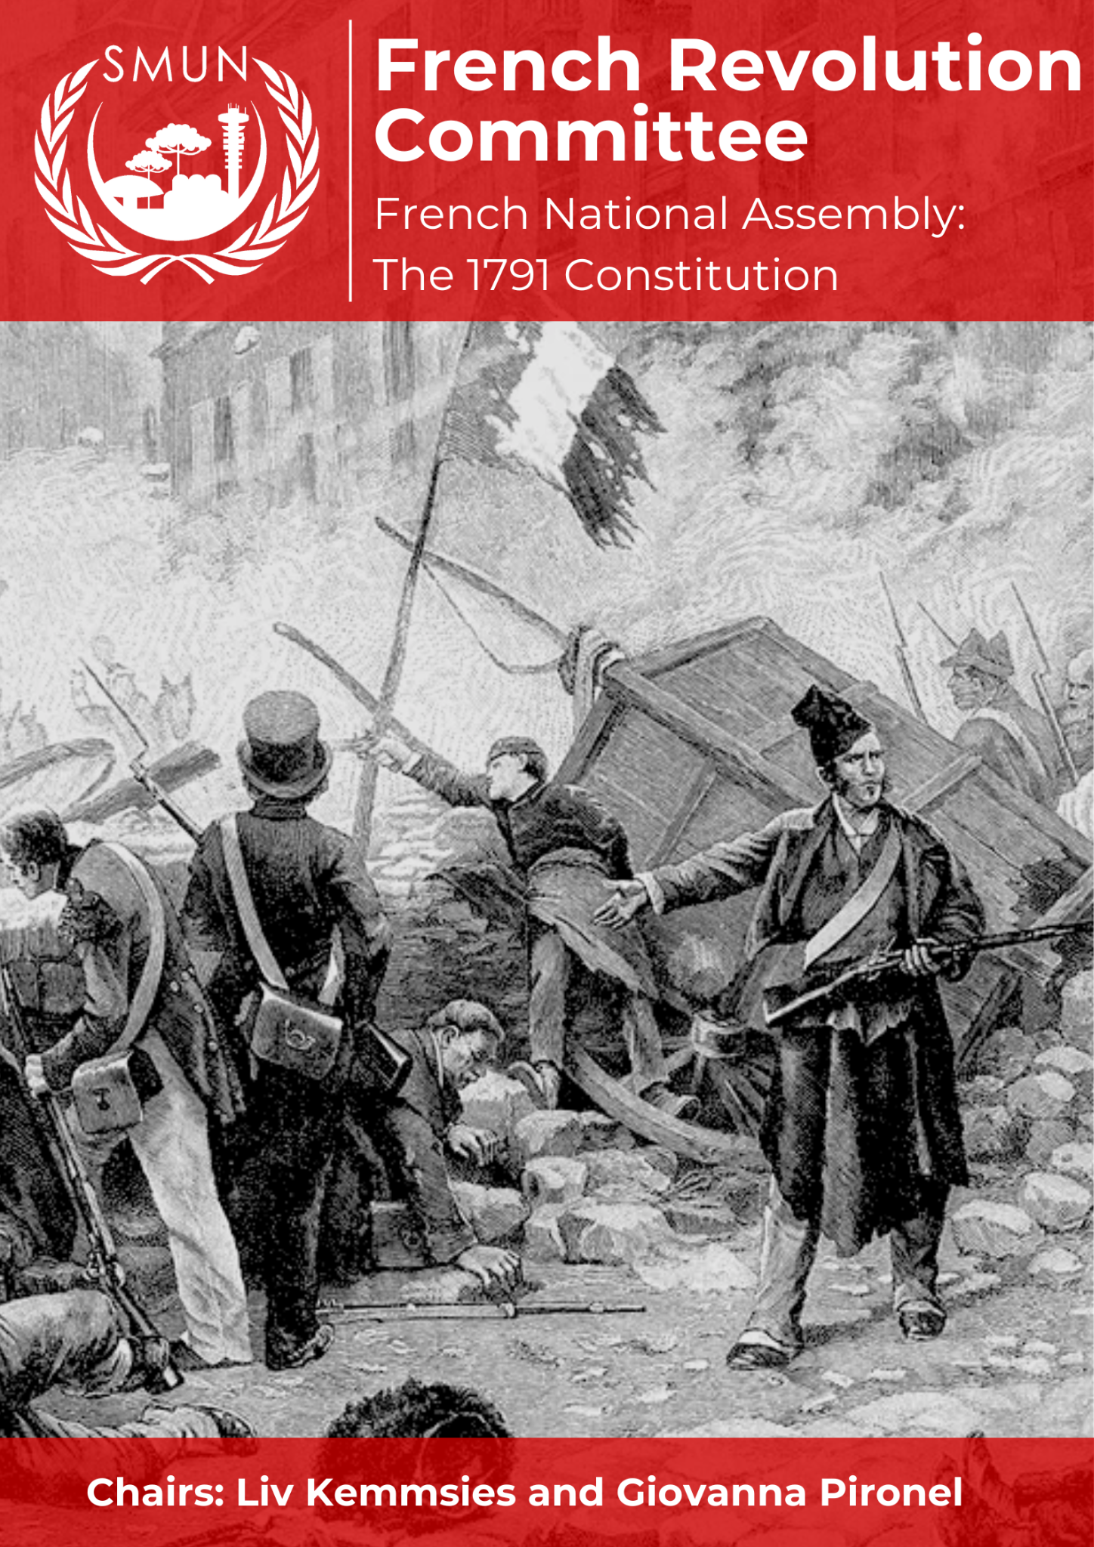

TABLE OF CONTENTS

LETTER TO THE DELEGATES 3
COMMITTEE DESCRIPTION 4
PARLIAMENTARY PROCEDURE 5
Personal Pronouns 5
Working Paper and Draft Resolutions (Constitution and Titles) 5
Position Papers 5
Directives 6
TOPIC: The Constitution of 1791 6
Historical background 6
The First Estate 7
The Second Estate 7
The Third Estate 8
Current situation 9
Timeline of events 11
Positions of deputies 12
Antoine Barnave 13
Adrien Duport 13
Alexander Lameth 13
Le Chapelier 13
Charles Lameth 14
Jean-Paul Marat 14
Maximilien Robespierre 14
Abbé Sieyès 15
Stanislas Marie Adélaïde Clermont-Tonnerre 15
Jean-Paul Rabaut Saint-Étienne 15
Marquis de La Fayette 16
Jérôme Pétion de Villeneuve 16
Louis-Michel Le Peletier de Saint-Fargeau 16
Charles-Maurice de Talleyrand-Périgord 17
Jean-Sylvain Bailly 17
Jean-Joseph Mounier 17
Honoré Gabriel Riqueti, Count of Mirabeau 17
Armand-Gaston Camus 17
Armand de Kersaint 18
Jacques Guillaume Thouret 18
Pierre-Louis Roederer 18
Gérard de Lally-Tollendal 18
Jean-Denis Lanjuinais 18
Jean-Siffrein Maury 19
Nicolas Bergasse 19
Jean-Baptiste-Marie Champion de Cicé 19
Pierre-Victor Malouet 19
Guiding questions 19
Further research 20
BIBLIOGRAPHY 21

LETTER TO THE DELEGATES
Dear Delegates,

I am Liv Kemmsies, currently in my third year of high school at the Swiss School of Curitiba. Throughout my MUN years, I have learned the importance of all perspectives; this couldn't be any different in SMUN. All positions during this conference are equally important to make this event unforgettable. My excitement about this symbiotic relationship between chairs and delegates is boundless, and I hope the feeling is mutual.

I'm Giovanna Oliveira Pironel, currently in my last year of high school, at the Colégio Everest International of Curitiba. During my MUN experience, I've realized how hard it is to overcome fears and insecurities, so if any of you need some help, do not hesitate to contact us. I am extremely excited to experience the debated theme and the interactions that we will have throughout the conference.

Discussing this complex yet beyond-important issue can determine the outcome of the most influential revolution France has faced. Subsequently, the actions you take during the debate affect the whole world. We chairs have the utmost confidence you will face this conference with respect, responsibility, and as much passion as we do.

Your Chairs,

Liv Kemmsies
liv.kemmsies@aluno.chpr.com.br
+55 41 98776-5579

Giovanna Pironel
giovanna.pironel@alunoseverest.curitiba.br
+55 15 99662-1106

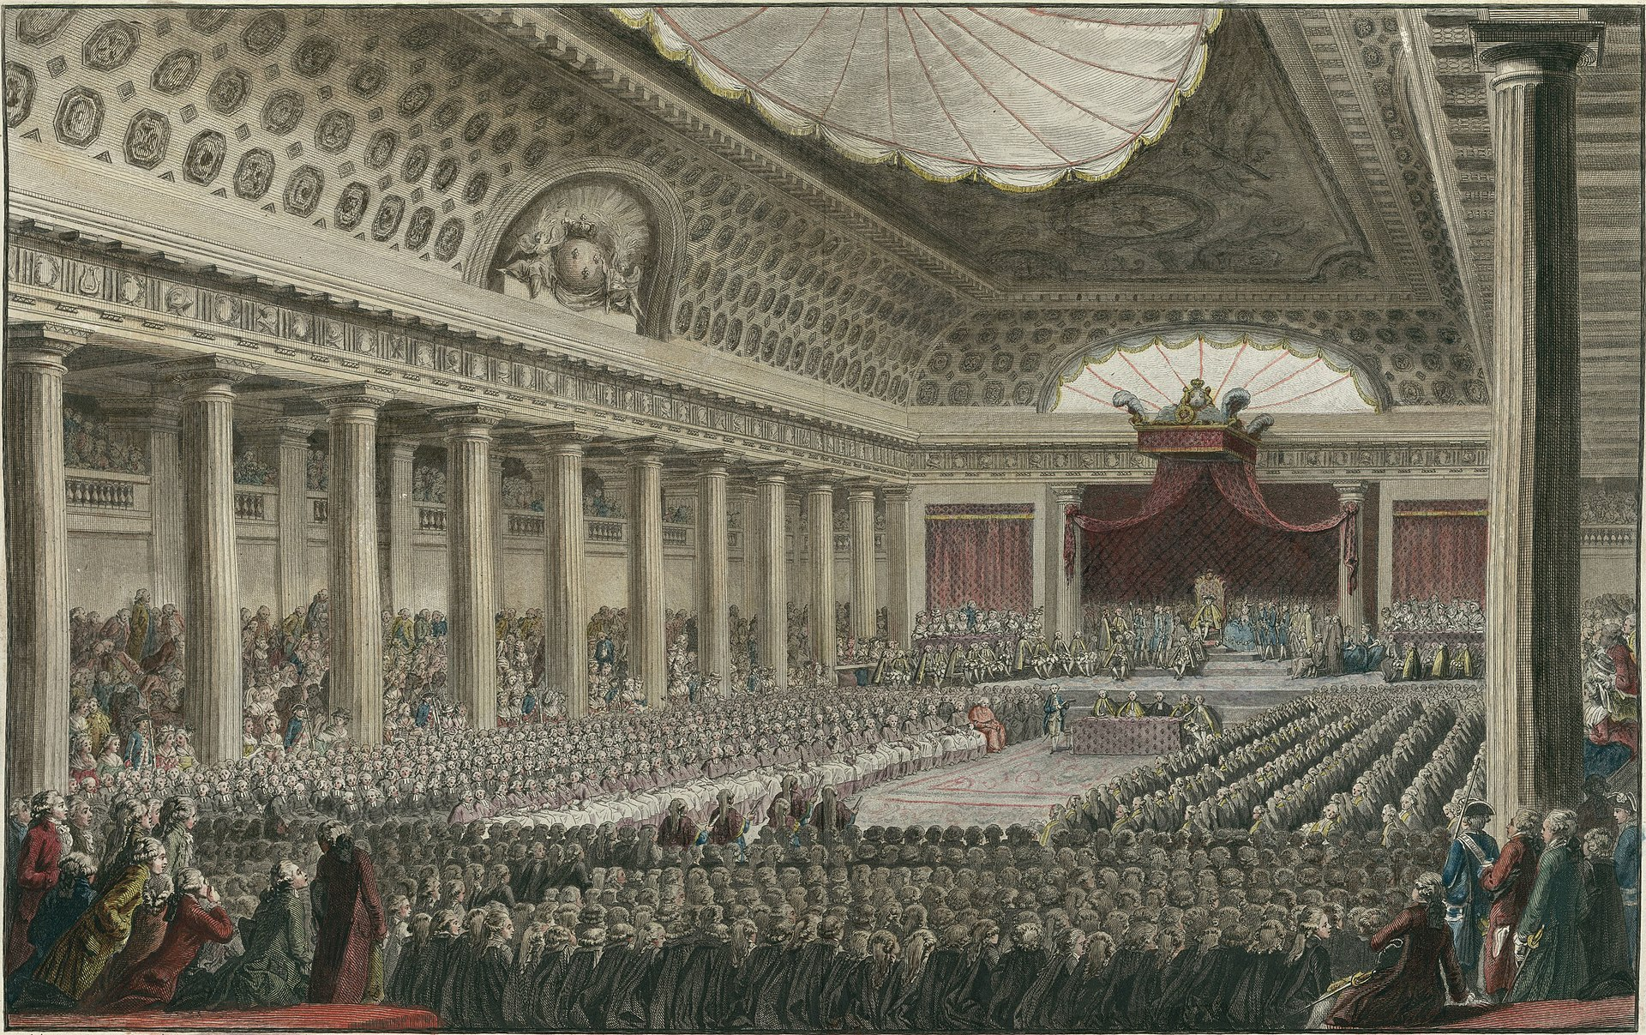
COMMITTEE DESCRIPTION

The French National Assembly, founded officially on June 17th, 1789, and renamed to National Constituent Assembly (July 9th) in the same year, had the purpose of writing the first-ever French constitution. After King Louis XVI decided to vote by Estate rather than by head in the Estates General, the enraged members of the Third Estate, the lion’s share of France’s population, pledged to the Tennis Court Oath (June 20th) to persist and remain civil until a Constitution of the Kingdom were composed. The National Constituent Assembly was dissolved and replaced by the Legislative Constitution, and by September 1791, a National Constitution had been written and approved. Since this committee took place on September 10th, 1789, the Assembly has not yet completed its duty of assessing pressing issues for France, such as poverty, financial instability, and social disparity.

PARLIAMENTARY PROCEDURE

Personal Pronouns
As you will be representing people instead of a country’s delegation, using personal pronouns - such as “I” and “you” - will be allowed. It is unnecessary to use pronouns matching the gender of historical figures being represented, so you may use the gender the deputy prefers.

Working Paper and Draft Resolutions (Constitution and Titles)
Since the goal of the debate is to determine how the government of France will be organized, the final Resolution will be addressed throughout the sessions and in the deputies' position papers, as the Constitution of 1791. However, the draft resolutions will not be directly an outlined version of the Constitution itself, but it will be the titles that will divide some topics that will be discussed throughout the conference, and determined by the agenda.
For example, if the deputies agree to discuss the political branch, there shall be a whole title (draft resolution paper) that discusses this topic, and how it will be developed in revolutionary France. For a title to be accepted by the Chair, there must be at least 3 deputies as adhérents principaux (main submitters) and 5 co-adhérents (co-submitters). When a deputy motion upon the presentation and voting of any title, the document shall be sent to the Chair (example of formatting in the SMUN Handbook) and it will be evaluated if the writing and content are good enough. Afterward, the deputies will have the opportunity to add amendments to the draft resolution.
Furthermore, by the end of the conference, every single title will be added up to one single document, which will be the French Constitution of 1791. Final voting will be open and the deputies’ vote might be: "in favor", "against" or "abstain" (only if by the beginning of the session the deputy presents themself as "present" and not "present and voting") of the Constitution. For it to pass, there shall be a simple majority of "in favor" votes. There shouldn't be any amendments directly to the Constitution.

Position Papers
Firstly, since this is a special committee, you should keep in mind that the writing process of the position paper is slightly different. As the discussion is taking place in an Assembly, you will be representing a person rather than a country, so you are allowed to write in the first person. While writing down the first paragraph, which shall have a small summary of the current situation, you may bear in mind that instead of writing down an unbiased contextualization, the deputy that you are representing shall have his point of view of the situation shown, creating some type of subjective telling of facts.
The following paragraph must contain a summary of your deputy's political beliefs and how they have already impacted the French Revolution scenario, before and during the current situation.
The last paragraph is the most important one as you need to summarize, based on your deputy's policy, what should be written in the constitution.

Directives
In this committee, to improve the flow of the debate and to add historical accuracy, deputies have the right to write directives, which are actions deputies can take independently of the rest of the assembly. Essentially, they are crisis suggestions, based on the individual power of each deputy. Such actions may be inducing mobs and riots, convoking the king, kidnapping/killing people, spotlighting economic changes or crises, etc. A vivid imagination is always welcome!
The chairs will provide you with a Google form in which you can send your directives, and it will remain private from the rest of the assembly until the chairs or the crisis committee evaluates it. For better results, we advise you to be as specific as possible, so it can have the effect you desire within the committee.

TOPIC: The Constitution of 1791

Historical background
To understand the French Revolution, it is essential to understand the context before the events rolled out and the social organization that was being re-established. In the Ancien Régime (“old order”), everyone, independent of gender or social class, was subject to the King, which meant the King had total authority over law and religion - essentially, an absolute monarchy. France had been under the regime of an absolute monarchy since the 10th century with the increasing practice of feudalism, lasting up to May 1789. This also meant that society was divided into estates, in which the laws applied were valid depending on the social group one belonged to, and that the government ruled over the people, instead of for the people. The estates into which France was divided were the clergy (first estate), the nobility (second estate), and the commoners (third estate).

The First Estate
The clergy counted 130,000 ordained members of every position in the Catholic church, the official and only religion allowed in France at the time: cardinals, archbishops, priests, monks, nuns, etc. This estate benefitted from various privileges, considering the enormous influence the church had not only on the French population but also because of the mutual prestige between the church and the monarchy. The church’s powers extended to governmental issues such as performing marriages, baptisms, and funerals and delivering education and charity for the poor. Since the church advertised the King as having the holy right to the throne, the church had immunity from paying taxes, which, in addition to its already considerable revenue of circa 150 million livres per year and ownership of 10% of French territory, ended up in the immense wealth of the clergy.
In the late 1700s, the Catholic church started to lose influence due to the increasing number of people drifting towards freemasonry, protestant religions, or general apathy towards the church. In November 1787, the Edict of Versailles was signed by Louis XVI and was a small step to withhold the authority of the church, by granting the non-catholic population civil rights but still not ceding them public worship or political rights.
Not only did the other estates slowly renounce the power of the first estate, but members of the clergy also felt injustice within the church. Many parish priests, although respected within their communities, were seen as lesser by higher members of the clergy, such as cardinals and archbishops, and had fewer rights. It was not uncommon for members of the clergy, in the Estates-General and later the National Assembly, to be in favor of the revolution, considering the majority of the deputies voted to represent the first estate were parish priests (208 deputies in the Estates-General).

The Second Estate
The second estate was composed of the French nobility, which was anyone with titles - Duc, Comte, Vicomte, Baron, Chevalier, etc - granted by the King. These titles could be attained hereditarily, because of personal merit, or venally - paying a hefty amount of money to rise socially. This intensified considerably the disparity between members of the nobility, who were already segregated into several ranks, depending on how nobility was acquired, how long the individual or family was considered noble, the influence they imposed on society, and their obedience towards social norms exclusive to the second estate.
To invest in a title was a risk: on the one hand, the nobility was exempt from paying taxes, enjoyed political privileges, and secured the status of future generations as nobility. On the other hand, expenses to become entailed varied from 20,000 to 50,000 livres, noblemen had to depend on their land and vassals for income, they were commonly indicted of deprivation, and success to have a more luxurious life was not guaranteed. To put the range of members of the nobility into perspective, there were nobles of the court (“courtiers”) who surrounded the King constantly, having access to the Palace of Versailles and royal celebrations, while the so-called hoberaux (old bird), the rural noble families, would have minimal distinctions of a member of the third estate.
Numerous members of the nobility were involved in the American Revolution, considering the military implications of which one could acquire a title, which directly affected their involvement and leadership in the Estates-General, and subsequently the creation of the Constitution. The rise of the Enlightenment and contact with liberal-leaning texts, due to the estate’s better access to education were also major causes for the support of the Revolution on behalf of members of the second estate. To take the cake, the progressively decaying French economy - a consequence of the kingdom’s involvement in the Seven Years' War (1756–1763) and the American Revolutionary War (1775–1783), and the setbacks of the outmoded harvesting methods and compromising climate on the country’s agriculture - had put pressure not only on the third estate but put the possibility of demanding taxes of the noble population on the table. This caused immense dissatisfaction among the nobility, being a predecessor for the summoning of the Estates-General.

The Third Estate
The commoners, composing the biggest slice of the cake as the third estate, were the backbone of the nation at 98% of the population. Still, they were neglected politically and economically, and burdened with demands of excessive taxes from the government, the church, and the landowners.
As with the other estates, a commoner’s lifestyle could vary tremendously, ranging from poverty-stricken beggars to thriving merchants. The biggest disparity occurred within urban areas, notably in Paris, the most populous city at the time. Extremely crowded and expensive housing, soaring unemployment and food prices, and increasing crime and prostitution rates were all symptoms of the overcrowded cities and the indifference to the third estate. Among the impressive amount of peasants, the wealthiest of the commoners, called the bourgeoisie, was gaining opulence and influence within society, only to the extent to which it was attainable. Still, the more prosperous merchants and business owners had a hard time establishing political relevance.
Although the release of Sieyès’ “What is the Third Estate?”, at the beginning of 1789, brought attention to the disparity between estates, stressing that the third estate was, in fact, the bedrock of the nation, the French Revolution cannot be oversimplified into the clash between social classes. All estates were involved in remodeling a dysfunctional government and outdated social organization, which were troubling every estate, in one way or another. Evaluating the effectiveness of each method of government democratically - in the Estates-General and later the National Assembly - was the only viable option at the moment. Considering as well the cultural shift the Enlightenment had introduced, offering ideas such as the division of the three powers (proposed by Montesquieu), the natural rights of man (proposed by Rousseau), and freedom of religion and expression against the clutch of the church and the monarchy (proposed by Voltaire).
The Revolution started with the culmination of the discontent with the disparity between and within social classes, as can be understood above. The decaying economic situation was the last drop for King Louis XVI to summon the Estates-General, and the deputies in the assembly took the opportunity to model society as they deemed just. Although, at the end of the revolution, France went back to being ruled by a monarch, the French Revolution is seen as a beacon for other revolutions throughout history.

Current situation
The year 1789 stands as a crucial moment in French history, marking the start of the French Revolution. This occurrence not only created changes in the economic, political, and social spheres but also demonstrated the importance of discussing topics that before were ignored by governments, such as the lack of food from the insufficient reaping and the French population's poor life conditions. On May 5, 1789, King Louis XVI called upon the Estates-General at Versailles, an assembly of representatives of the three Estates. The importance of such an event is marked by the point that since 1614, there was no Estates-General Assembly since France was ruled by an absolutist monarchy, and it was the Estates-General was an opportunity for the population to voice its opinion.
On June 17, 1789, followed by the frustration caused by the voting method conducted in the Estates-General Assembly, the Third Estate declared the National Assembly. This decision symbolized a break from monarchical government and for the first time, a way to articulate the difficulties of the commoners and the inequities of the realm. Shortly after, on June 20th, the pledging of the Tennis Court Oath marked the promise of a Constitution.
On July 14, the most important event of the French Revolution happened the Storm of the Bastille, marking the uprising power of the population over the absolutist power. The prison Bastille was a symbol of royal political repression since it was the place where every single political enemy of the King was kept, and was stormed by revolutionaries who freed political prisoners. This became an emblem of the Revolution, as it was the moment that the population's satisfaction turned into something destructive for the French absolutist monarchy. Coincidentally, on this day, the first efforts to write a constitution started.
Between the 4th and the 11th of August of the same year, as a reaction to the Storming of the Bastille, the August Decrees were written to declare the end of seigneurial feudalism and the tithes. This was an enormous act to further dilute the First and Second Estate's power, directly affecting the income of both estates’ members.
Topping the rebellious actions, the National Assembly assumed the Declaration of the Rights of Man and the Citizen on August 26th. Motivated by Enlightenment doctrines, this document asserted the inherent rights of every single individual and stood in favor of the main principles such as equality before the law, and freedom of speech and religion.
Now, on September 10th, 1789, the National Assembly has just voted successfully on the implementation of a unicameral legislative assembly, but issues such as the power of veto of the king and the relevancy of the parliaments are still issues whose voting on are imminent.

Timeline of events
The early 1700s - France’s peak at the beginning of the century was certain with the nation’s wealth, undeniable cultural influence upon other European nations, resilient military, and being “a bastion of Catholicism”, among other advances.
1721 - Montesquieu releases his first major book, Lettres Persanes, which mocks Louis XIV’s recently ended govern, social classes, and the Catholic Church, as well as explores ideas of the nature of the state.
1734 - Voltaire concludes Lettre Philosophiques, in which he critiques forced religion and political and social systems.
1756 to 1763 - The kickoff of the Seven Years’ War substantially increases France’s debt.
1762 - Jean-Jaque Rousseau writes Du Contrat social, arguing that laws should only be biding if the general public is in accord with them, challenging the legislative system in which laws were administered solely by the King.
1775 to 1783 - The American Revolutionary War begins. France once more is involved with the war by financing it, aggravating its economy even more, costing France, in total 1.8 billion livres.
1778 to 1783 - France formally declares war with Britain over the control of the English Channel, the Indian Ocean, and territories in the Mediterranean, and Caribean.
1787 - After Calonne was promoted as finance minister, he advised Louis XVI to summon the Assembly of the Notables - composed of high-ranking nobility and clergy - to pressure the parliament to approve new taxation laws, which allowed the taxation of the second estate. Calonnes attempt did not work, as the second estate opposed Calonne’s solution to France’s financial bankruptcy.
January 1789 - Emmanuel Sieyès publishes the What is the Third Estate? pamphlet.
May 5th, 1789 - The Estates-General meets in Versailles for the first time in 175 years. Jaques Necker announces that votes will be held by order rather than by head.
June 17th, 1789 - The representatives of the third estate, notably Emanuel Sieyès, invite the representatives of both other estates to join the third estate in a national assembly. On this day, the National Assembly of France is voted on and approved.
June 20th, 1789 - The deputies of the national assembly plead, in a tennis court, to remain active until a constitution is composed, later on known as the Tennis Court Oath.
July 11th to August 26th, 1789 - Lafayette, based on the American Bill of Rights, proposes to draft a declaration of rights. This document was written and later passed by the now National Constitutional Assembly in August as the “Declaration of the Rights of Man and Citizen”.
July 14th, 1789 - Along with the storming of the Bastille, a prison in eastern Paris, the drafting of the Constitution of 1791 begins.
August 4th to 11th, 1789 - In response to the storming of, the August Decrees are composed, in which, among other orders, the seigneurial feudalism was disassembled and the tithes were banned.
September 10th, 1789 - With 849 to 89, the National Constituent Assembly votes for a unicameral legislative assembly.

Positions of deputies
It is important to note that not all deputies in this committee were present during the same periods. In this conference, you will discuss topics debated for three years during the actual revolution (1789-1791. We ask you all to thoroughly research your figures’ opinions rather than concentrating on their immediate involvement in writing the 1791 Constitution, keeping in mind the adaptations we made to accommodate two years into three days of debate.

Antoine Barnave
Antoine Barnave was elected a representative of the third estate of Grenoble, his hometown, and quickly established great influence, by forming the Triumvirate with Alexandre Lameth and Adrien Duport, defenders of the Jacobin club. He was often in opposition to Honore Mirabeau but defended a constitutional monarchy, in which the monarchy would govern in accord with the constitution, rather than with full authority. Still, he advocated for the freedom of speech and religion, being in favor of a suspensory veto.

Adrien Duport
Adrien Jean-Francois Duport, a representative of the second estate of Paris, had much more radical views than his co-founders of the Feuillant club, which aimed for a neutral stand - intending to have the support of both the right and left. In various debates, he strongly voiced his reformist opinions about the penal code, his opposition to the death penalty, the fourth condition of eligibility and the ownership - rather than management - of ecclesiastical property, and his support for the integration of Jews in the political scene.

Alexander Lameth
Alexandre-Théodore-Victor Lameth, as his brother, represented the third estate within the National Assembly, albeit their acclaim for their participation in the American Revolutionary War. His main contribution to the composing of the Constitution was his input on the organization of the French military. His ardent hostility towards Mirabeau was especially noticeable due to his decree against the parlaments, on the grounds of their irresponsibility towards France’s financial failure.

Le Chapelier
Isaac Rene Guy le Chapelier, one of the most involved deputies in the writing of the Constitution, constantly voiced his extreme radical ideas. He not only pioneered the Jacobin club, which emanated from Le Chapelier’s Breton club but proposed to banish any titles and the nobility as well, which shined a light on his leadership considering how own nobility. Yet, his opinions shifted right pointedly regarding the workings’ associations, originating the “Le Chapelier Law”, banning the formation of guilds or strikes.

Charles Lameth
Charles Malo François Lameth was a trailblazer in regards to his being one of the first members of the nobility to renounce their privileges as a way of showing his solidarity with the people of France. An extremely popular figure who advocated that France should follow the path of a constitutional monarchy to preserve tradition while moving the nation forward. Staunchly on the side of the Feuillants, as is his brother Alexander, Charles wishes to protect the interests of the people through a democratic government that works alongside the monarch.

Jean-Paul Marat
Jean-Paul Marat, the great Swiss-born Frenchman, is the most famous of the radical Jacobins, along with being their most popular member. The bridge between radicalism and the populace, Marat is an advocate for terrorism as a way of bringing down the tyrannical monarchic government of France. The idealist responsible for the motto of the revolution was “No Gods, No Masters." Marat advocates for the complete dismantling of the political system of France for a constitutionalist system that protects the rights and liberties of men from the ashes of the former system.

Maximilien Robespierre
Maximilien François Marie Isidore Joseph de Robespierre is, undoubtedly, the most divisive and influential figure of the French Revolution, being described as “the personification of the Revolution”, “upholder of the wretched, avenger of the innocents” and, in 1790 “the Incorruptible”. His path to his grandiose reputation began as a lawyer in Artois, and later the representative of the third estate of Artois in the Estates-General. As a deputy in the National Assembly, he delivered nearly 500 speeches in which he adamantly defended universal suffrage, the freedom of speech and religion, and the rights of Jews, for France to become a republic. Even his adversaries, such as Mirabeau and Barnave, marveled at and spoke highly of his persuasiveness.

Abbé Sieyès
Emmanuel Joseph Sieyès had an astronomical effect on the third estate due to his pamphlet “What is the Third Estate?”, granting him the opportunity to represent the commoners, albeit belonging to the clergy. His early efforts within the Estates-General, aligned with the arguments presented in his pamphlet introduced the conception of the National Assembly. He argued against the King’s right to absolute veto and the banning of the tithes in the August decrees. Later on in 1790, he condemned the assembly regarding the “Civil Constitution of the Clergy”, which made the Catholic Church subordinate to the French government, estranging many from the Revolution, claiming “they wish to be free but they do not know how to be just”.

Stanislas Marie Adélaïde Clermont-Tonnerre
Stanislas, being from a noble aristocratic French family, was another revolutionary who opted to fight for the people rather than for the monarchy. A great defender of the rights of men, especially standing vehemently on the side of minorities such as Jews. Stanislas is also against a bicameral system and veto power for the monarchy, though he remains a moderate royalist due to believing that the old system and a new one may work in harmony as he is deeply inspired by the “Organic Laws” of England.

Jean-Paul Rabaut Saint-Étienne
Jean-Paul Rabaut Saint-Étienne had marked his ascension in politics when chosen as deputy of the Third State of Nîmes and Beaucaire, on March 27, 1789. By taking the Tennis Court Oath, he became secretary by November of the same year, and later on President of the assembly in 1790. While thinking of the deputy's contribution to French politics, one of the most important points that must be discussed is how this deputy contributed to the Declaration of the Human Rights (1789), by affirming that "freedom of thought and opinion" is "an inalienable and imprescriptible right", and that "the rights of all French people are the same".

Marquis de La Fayette
Marie-Joseph Paul Yves Roch Gilbert du Motier de La Fayette, the nobleman who fought for the Americans in their revolution, has now returned home to help settle the revolution in France. Driven by the spirit of change and reform, Lafayette stands on the side of the people, and that's why he firmly believes that voting should happen by head and not by social class. With the help of Thomas Jefferson, Lafayette put forth the “Declaration of the Rights of Man and of the Citizen,” which was deeply based on the ideas of the Enlightenment, along with setting up the core values for the revolution to pursue, such as individual liberties and democratic ideals. Furthermore, Lafayette stands for a strong central government for the people by the people that put an end to slavery.

Jérôme Pétion de Villeneuve
Jérôme Pétion de Villeneuve is an important historical figure, who by the beginning of the French Revolution has demonstrated extreme participation and influence in the decisions. During the National Assembly, this deputy, by the side of Robespierre, defended the independence of the lower classes and some democratic reforms. He may be considered a Jacobin leader, however there are some connections between Villeneuve and the Girondins, without actually breaking ties with the Jacobins party.

Louis-Michel Le Peletier de Saint-Fargeau
Louis-Michel Le Peletier de Saint-Fargeau was a crucial figure in the French Revolution and the aftermath of such a historical moment. In the Constituent Assembly, he gained popularity, which led him to become president of the Constituent Assembly in 1790. Some of the ideas that he disseminated to the Assembly were the substitution from beheading to hanging and even the banning of the death penalty. The Jacobin leader, Robespierre, used to accept and support most of the ideals defended by Saint-Fargeau.

Charles-Maurice de Talleyrand-Périgord
Talleyrand was a first estate deputy, elected by the clergy who defended a multitude of reforms to the status of the clergy, and defended a constitution that provided a representative government, and that assured equality to the people, particularly aiming at the abolishment of fiscal privileges, therefore meaning fiscal equality as well.

Jean-Sylvain Bailly
In May of the year 1789, Bailly, an astronomer and politician, was chosen president of the French Third Estate. He led the proceedings at the Tennis Court Oath in June of that same year, where deputies pledged to remain united until a constitution to France had been written and established. He would later be elected Paris’ first mayor on July 15th of that year, later retiring from his political career and re-focused on scientific research again.

Jean-Joseph Mounier
Mournier was a Third-Estate patriot deputy and the author of the Tennis Court Oath. The deputy was founded in August of 1789 by the Monarchiens party, in defense of a monarchic constitution, which was quickly dissolved. He embraced the original ideals of the French Revolution but soon became very cautious of the radicalization of ideas in the country.

Honoré Gabriel Riqueti, Count of Mirabeau
The Count of Mirabeau was a Third-Estate deputy, who was profoundly against the idea of despotism, but in turn, was a firm supporter of a Constitutional Monarchy, admiring the constitutional document of the English, and desiring to replicate its achievements in that of the French.

Armand-Gaston Camus
Camus was a deputy on the French Third Estate and was appointed the archivist to the “Commission des Archives of the Assembly” on August 14th, 1789. His speeches at the Estates-General were notable for his targeting social inequalities, being himself an austere republican, and being one of the most active speakers at the Assemblies.

Armand de Kersaint
Kersaint was a sailor and politician elected for the First Estate but was very intimately involved with the ideas of the Third Estate, especially because of his military involvement. He defended general reforms of all institutions and condemned feudal privileges, also advocating for fiscal reform.

Jacques Guillaume Thouret
Elected deputy by the Third Estate, Thouret gained great influence for his eloquence. He opposed the clergy and was a supporter of the secularization of the church’s property. He advocated for the suppression of ecclesiastical privileges, and actively contributed to changes within the judiciary and administrative privileges.

Pierre-Louis Roederer
Pierre-Louis Roederer was an important economic and political figure, who was elected as a deputy, by the Third Estate, on the Estates-General Assembly. He was not present at the event in June 1789, however, he put Jacques-Louis David to represent him in the Tennis Court Oath.

Gérard de Lally-Tollendal
Supported the Revolution by the beginning of it, however with the progression of events, Tollendal stopped his support, since the new government's ideologies were getting into conflict with the deputy's conservative thoughts and beliefs. Such a situation made him start supporting the movement Le Ancien Régime, which supported the return of the absolute monarchy, remaining completely royal to King Louis XVI.

Jean-Denis Lanjuinais
Elected as a deputy of the Third Estate on April 17, 1789, playing a crucial role in the Estates-General Assembly. He always demonstrated completely against the feudal privileges and demanded political and social reforms. While drafting the Civil Constitution of the Clergy, he advocated for national unity of the Church under civilian control, something that afterward led to the Gallican Church, which is independent of foreign influence and aligned with civil principles.

Jean-Siffrein Maury
Maury was a cleric and represented the First Estate in the Estates General. He was acknowledged leader of the court and Church party. He was a fierce adversary of the Count of Mirabeau, with whom traded heated speeches during the Assemblies. He defended the Absolute Monarchy, and the Church during his time as a deputy.

Nicolas Bergasse
Nicolas Bergasse was an extremely important publicist and lawyer during the French Revolution. His connection with the Kornman trial, in 1788, just brought out all the corruption and justice issues within the ancient regime. Bergasse's influence was not restrained in the courtroom, quite the opposite, he was considered by the eyes of the public as a symbol of the quest for liberty and the rule of law.

Jean-Baptiste-Marie Champion de Cicé
Jean-Baptiste-Marie Champion de Cicé was elected deputy of the clergy in 1789, he defended the rights of his order, disagreeing entirely with the Declaration of the Human Rights, and he associated himself with every single "right" protest.

Pierre-Victor Malouet
Was elected as a deputy for the Estates-General in 1789, Malouet demonstrated to be a monarchist ideologist, however, supported social and economic reforms, and the selling of the Church's lands. Malouet co-founded a monarchist club that balanced the influence of populist societies and the Jacobins.

Guiding questions
- To what Estate does your deputy belong?
- Who does your deputy defend the right to vote?
- How does your deputy believe the powers (judiciary, legislative, and executive) should be distributed?
- Does your deputy defend the right of veto for the king? To what extent would his veto be valid?
- To what extent does your deputy defend the monarchy? What other types of government does your deputy suggest/defend?

Further research
- NATIONALE, A. Assemblée nationale - Les députés, le vote de la loi, le Parlement français. Available in:: <https://www.assemblee-nationale.fr>
- NATIONAL, A. National Assembly - French Constitution of 1791. Available in: <https://wp.stu.ca/worldhistory/wp-content/uploads/sites/4/2015/07/French-Constitution-of-1791.pdf>
- FRENCH REVOLUTION TOPICS. Available in: <https://alphahistory.com/frenc
hrevolution/french-revolution-topics/>
- FRANCE, National Assembly of. Available in: <https://constitutionnet.org/sit
es/default/files/declaration_of_the_rights_of_man_1789.pdf>

BIBLIOGRAPHY
Mark, Harrison W. “Flight to Varennes.” World History Encyclopedia, www.worldhistory.org/Flight_to_Varennes/#google_vignette.
"French Constitution of 1791." World History, wp.stu.ca/worldhistory/wp-content/up
loads/sites/4/2015/07/French-Constitution-of-1791.pdf
Mark, Harrison W. “Excerpts from What Is the Third Estate.” World History Encyclopedia, 22 Aug. 2022, www.worldhistory.org/article/2061/excerpts-from-wha
t-is-the-third-estate/.
Mark, Harrison W. “American Revolutionary War.” World History Encyclopedia, www.worldhistory.org/American_Revolutionary_War/.
“Assembly of Notables.” Wikipedia, 10 July 2024, en.wikipedia.org/wiki/Assembly_of_Notables#1787_assembly.
‌“List of Members of the National Constituent Assembly of 1789.” Wikipedia, 3 Dec. 2023, en.wikipedia.org/wiki/List_of_members_of_the_National_Constituent_Assem
bly_of_1789.
“Jean-Paul Rabaut Saint-Étienne (1743-1793).” Museeprotestant.org,museeprotest
ant.org/notice/jean-paul-rabaut-saint-etienne-1743-1793/. ‌
"Jérôme Pétion de Villeneuve." Encyclopaedia Britannica, Encyclopaedia Britannica, Inc. https://www.britannica.com/biography/Jerome-Petion-de-Villeneuve. ​​
"Pierre Louis Roederer." Wikipedia: The Free Encyclopedia, Wikimedia Foundation, 8 Feb. 2024, https://en.wikipedia.org/wiki/Pierre_Louis_Roederer.
Assemblée nationale. "Fiche de 12286." www2.assemblee-nationale.fr, https://www2.assemblee-nationale.fr/sycomore/fiche/%28num_dept%29/12286.
"Fiche de M. Charles de Gaulle." Assemblée nationale, www2.assemblee-nationale.fr/sycomore/fiche/(num_dept)/12851.

"1794 Cardinals of the Holy Roman Church." The Cardinals of the Holy Roman Church, Florida International University, https://cardinals.fiu.edu/bios1794.htm#Maury
Assemblée nationale. "Nicolas Bergasse." Base de données des députés français depuis 1789, https://www2.assemblee-nationale.fr/sycomore/fiche/(num_dept)/12588.
National Assembly of France. "Fiche de député: Jacques Bompard." Assemblée Nationale, https://www2.assemblee-nationale.fr/sycomore/fiche/(num_dept)/11815.
Assemblée nationale. "Fiche de 11815." Sycomore, https://www2.assemblee-nationale.fr/sycomore/fiche/(num_dept)/11815.
"Charles-Maurice de Talleyrand, prince de Bénévent." *Encyclopaedia Britannica*, 2023, https://www.britannica.com/biography/Charles-Maurice-de-Talleyrand-prince-de-Benevent.
"Jean-Sylvain Bailly." Encyclopædia Britannica, Encyclopædia Britannica, Inc., 23 Oct. 2023, www.britannica.com/biography/Jean-Sylvain-Bailly.
"Restructuring France." Encyclopædia Britannica, Encyclopædia Britannica, Inc., https://www.britannica.com/place/France/Restructuring-France#ref465201.
“Sir William Hamilton (1730–1803).” British Museum, The Trustees of the British Museum, https://www.britishmuseum.org/collection/term/BIOG234283.

